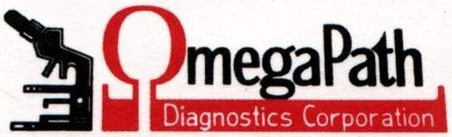

OmegaPath is dedicated to providing the highest quality service. We accept the vast majority of insurances and we offer second opinion consultation services.

If you have any questions
Call Ms. Edythe Trino,
Mr. Anthony Trino or Robert O. Jones, MD


EXCELLENCE IS A HABIT, NOT AN EVENT ARISTOTLE
IF YOU WOULD LIKE QUALITY SERVICE FOR YOUR BIOPSY OR PAP SMEAR HAVE IT SENT TO
OMEGAPATH DIAGNOSTICS
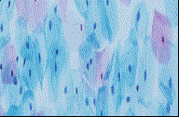
1600 Broad St
Utica, NY, 13501
Phone: 315-793-8970
Toll Free: 866-501-8971
Fax: 315-733-1624
OmegaPath.com
E-mail: OmegaPath@mail.com
Omegapath Diagnostics, Corporation

The Laboratory Dedicated to Providing the Highest Quality Service to You


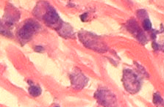
OmegaPath Diagnostics, Corporation is a state of the art Anatomic Pathology laboratory. We specialize in tissue biopsy and cytology interpretation.

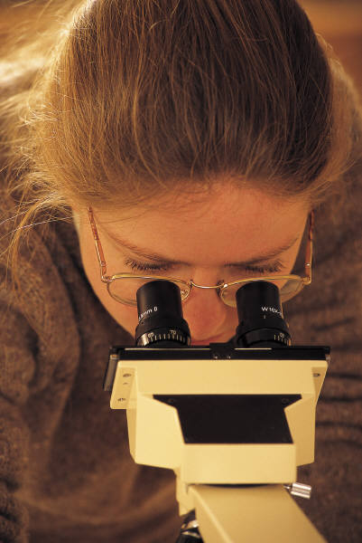
Our emphasis is on total quality of service. This includes continuous training and updating of our staff, providing accurate interpretation of cytology and biopsy specimens in a timely manner (usually within 24 to 48 hours from receipt of the specimen in uncomplicated cases). OmegaPath is accredited by the College of American Pathologists (CAP) and our Pathologists and cytotechnologists are board certified. Our goal is to provide you, the patient with an accurate pathologic diagnosis in a timely manner.

As is often the case, a number of questions arise in regards to our services. We will provide you with the answers to some of the most frequently asked questions.

F A Q’s [FREQUENTLY ASKED QUESTIONS]
Q: What is Anatomic Pathology?
A: Anatomic Pathology is the study and diagnosis of tissue specimens including biopsies and/or cells (cytology) obtained from the body such as Pap smears.
Q: What is involved in the diagnosis of my biopsy?
A: Once your doctor does the procedure to obtain the biopsy, the resultant tissue is put in preservative and sent to OmegaPath. We further process the tissue such that we can look at it through a microscope and give your doctor a diagnosis.

Q: What is involved in diagnosing Cytology, including Pap smears?
A: The specimen is processed and stained with dyes and looked at under the microscope by a cytotechnologist. This is called being “screened” by the cytotechnologist. If there are any abnormalities on the Pap smear then it is reviewed by the Pathologist. Other cytology specimens such as fine needle aspiration biopsies are automatically reviewed and diagnosed by the Pathologist and biopsies go directly to the Pathologist.

Q: What does the cytotechnologist do and what type of training is required?
A: The cytotechnologists “screen” the Pap smear. A cytotechnologist has to have graduated from college and then completed a one-year course in cytotechnology.
Q: What does the Pathologist do and what type of training is required?
A: Pathologists are Medical Doctors who have trained in Pathology (five to seven years) after medical school. Pathologists look at your biopsy or Pap smear under the microscope and give your doctor a diagnosis based on their observation and your clinical history.
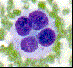

OMEGAPATH DIAGNOSTICS
- ACCEPTS MOST INSURANCES

- BOARD CERTIFIED PATHOLOGISTS

- BOARD CERTIFIED CYTOTECHNOLOGISTS

- COLLEGE OF AMERICAN PATHOLOGY CERTIFIED WITH DISTINCTION

